Lab-sheet 6

1.

i. What is the distribution of X?

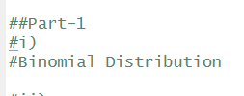

ii. What is the probability that at least 47 students passed the test?

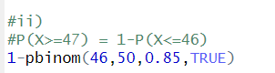

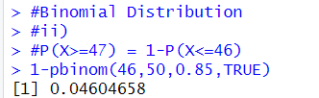

2. A call center receives an average of 12 customer calls per hour.

i. What is the random variable (X) for the problem?

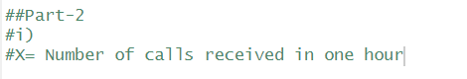

ii. What is the distribution of X?



iii. What is the probability that exactly 15 calls are received in an hour?

